**Question 4**

Suppose that domestic demand for mobile phones (in thousands) in Australia is given by P = 1600 – 2Q, supply is given by P = 2Q, and the world price of mobile phones is $400.

A. How many mobile phones will Australia import or export under free trade?

B. Suppose the government imposes a $200 per phone tariff on mobile phones. How much tariff revenue will this policy generate, and how much will be the deadweight loss?

**Answer:**

1. World price=400 Q(demand)=600,000 Q(supply)=200,000

Imports=400,000

1. Tariff revenue=(500,000 - 300,000) *(600 - 400)=40,000,000

Deadweight loss=1/2 *(300,000 - 200,000) *(600 - 400) +1/2 *(600,000 - 500,000) *(600 -400)=20,000,000

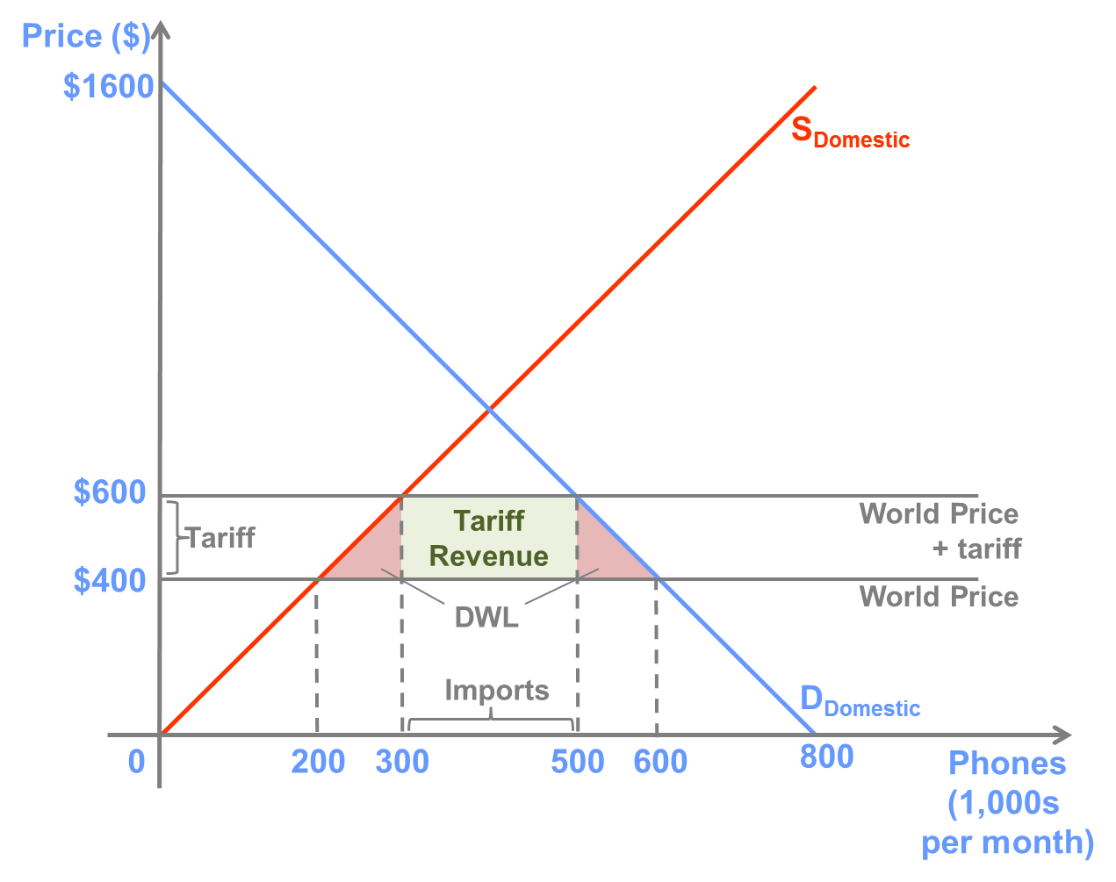

**Question 5**

Suppose that the domestic market for televisions can be depicted by the following graph:

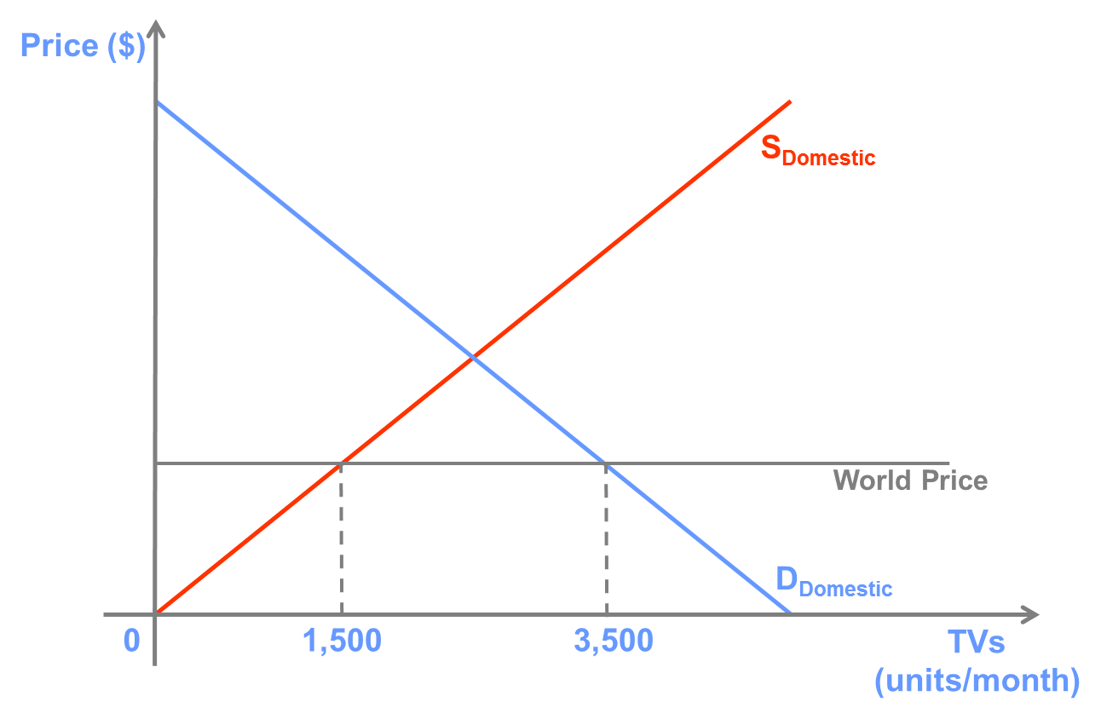

A. Compared to free trade, show on the graph what will happen to the market price and quantities produced and consumed if the government imposes a 1,000 TV/month import quota.

B. Now, show on the graph how consumer surplus, producer surplus, and total surplus will change.

**Answer:**

A.

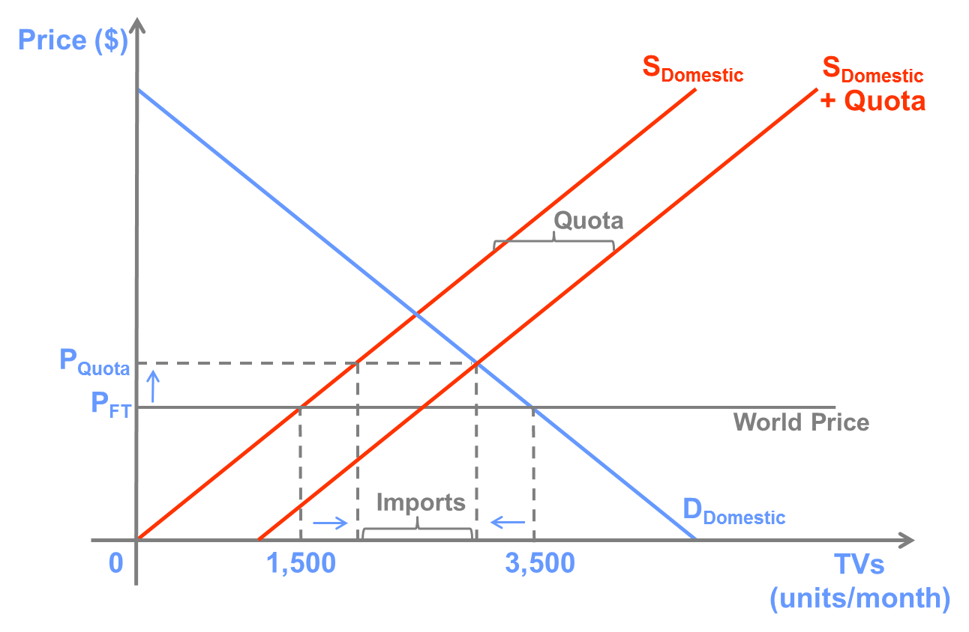

The market price increases from PFT to PQuota, the quantity supplied by domestic producers increases, and the quantity demanded by domestic consumers decreases.

B.

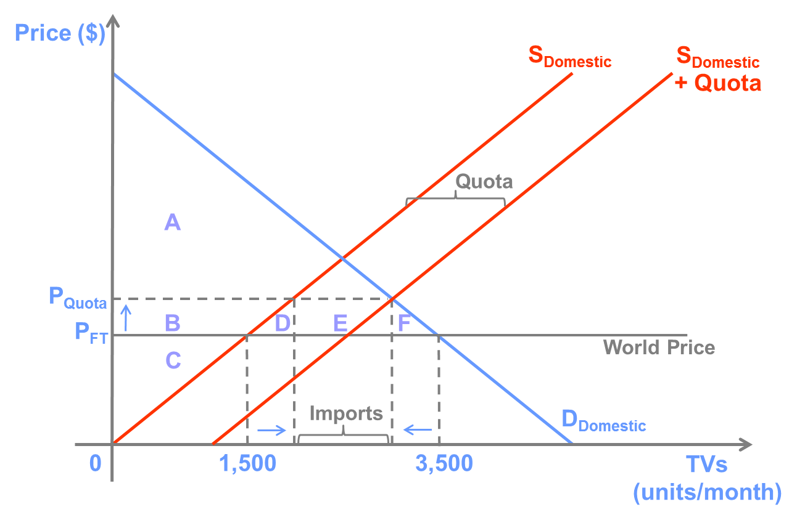

Consumer surplus decreases by an amount equal to the area of B + D + E + F, and producer surplus increases by an amount equal to the area of B. Total surplus decrease by an amount equal to the area of D + F.

The remaining surplus, equal to the area of E, could go to the government, importers, or someone else depending on how the government allocates the right to import the 1,000 TVs allowed per month.

Quantities of supply increase, cannot say supply increases